Geometry: Unit 1, Lesson 2

- A right angle is an angle measuring exactly how many degrees?

90°

- What is the image shown an example of?
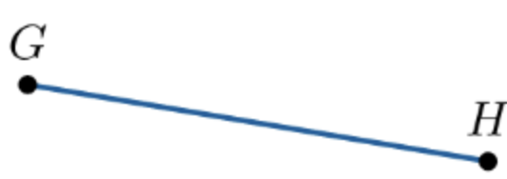

A line segment

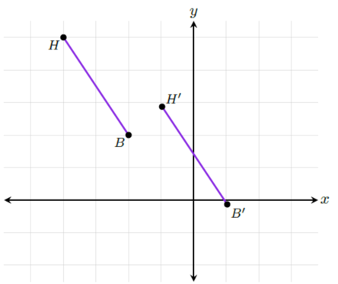

- A transformation is shown. What transformation is applied to the preimage?

Translation

